INFOSYS SPRINGBOARD BATCH 13

AI Enabled Conversational IVR Modernization Framework

Module 1: Legacy System Analysis and Requirements Gathering
Objective
Assess the existing VoiceXML (VXML)–based hospital IVR system and define the technical and functional integration requirements required to modernize the system using Twilio, while maintaining compatibility with existing hospital backend systems.
Task 1: Review the Architecture and Capabilities of Existing IVR Implementations

  - Overview of the Existing Hospital IVR System
The existing hospital IVR system is implemented using VoiceXML and follows a traditional, menu-driven interaction model. The system is designed to handle common hospital-related services such as appointment booking, appointment status checks, laboratory report inquiries, billing information, and call routing to reception or emergency services.
Caller interactions are primarily handled through keypad-based DTMF input. Each service is accessed by navigating predefined menu options, making the system reliable but rigid in handling patient requests
1.2 High-Level Architecture of the Legacy Hospital IVR
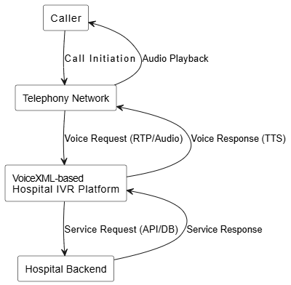

  - Hospital IVR Call Flow Structure
The hospital IVR follows a hierarchical and linear call flow structure:
- Call enters through a fixed entry point
- Welcome prompt is played
- Department-level menu is presented
- User selects a service using DTMF input
- Required patient information is collected
- Backend systems are invoked
- Response is played to the caller
- Call is terminated or transferred to a hospital staff member
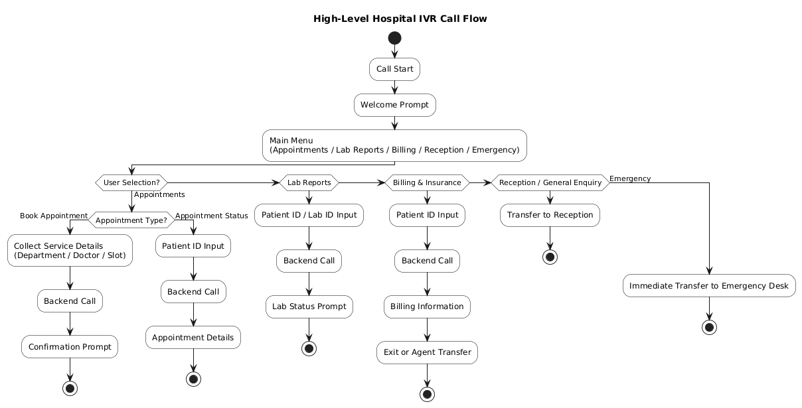

  - VoiceXML Capabilities Used in the Hospital IVR
The hospital IVR system uses standard VoiceXML components:
- <prompt> – Delivers recorded or text-to-speech messages to patients
- <menu> – Presents service options and routes calls based on DTMF input
- <field> – Collects patient-specific information such as Patient ID or Appointment ID
- <form> – Organizes prompts, menus, and logic into executable units
- Event handling (noinput, nomatch, error) – Handles incorrect or missing user input
These components ensure predictable and controlled call flow execution.
  - User Input Handling
- User interaction is primarily handled using DTMF (Dual Tone Multi Frequency) input
- Each keypad press generates tones detected by the IVR platform
- Inputs must exactly match predefined menu options
- No intent recognition or natural language understanding is supported
This approach ensures reliability but limits user flexibility, especially for elderly or distressed patients.

Task 2: Task 2: Document Integration Needs for Alignment with Twilio and AI Capabilities
2.1 Need for Twilio Integration in Hospital IVR
The legacy hospital IVR system does not support conversational interaction or intelligent call handling. Patients often prefer to describe requests verbally (e.g., “I want to check my appointment”) rather than navigating multiple menu levels.
Integrating Twilio introduces a modern voice interaction layer that enables AI-driven capabilities, such as:
- Speech-to-Text (STT)
- Intent detection and natural language understanding
- Intelligent call routing
- Improved error handling
These capabilities enhance usability while preserving existing VoiceXML-based IVR logic as a fallback.

2.2 Proposed Integration Architecture with Twilio
Twilio is introduced as an intermediary interaction and logic layer between the VoiceXML IVR and hospital backend systems.
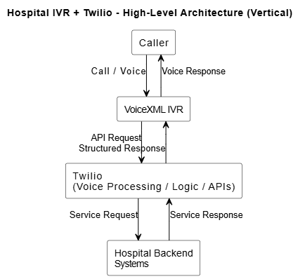

2.3 Functional Integration Requirements
The integrated solution must support:
- Forwarding of call context and user input from VoiceXML IVR to Twilio
- Hybrid interaction using DTMF and speech
- AI-based interpretation of user intent
- Intelligent routing to appropriate hospital services
- Backend invocation based on interpreted intent
- Structured responses suitable for voice playback
- Fallback to legacy IVR menus when AI services are unavailable

2.4 Technical Integration Requirements
- API-based communication between VoiceXML IVR and Twilio
- Unique call/session identifiers across systems
- Real-time processing suitable for live hospital calls
- Secure communication with hospital backend systems
- Minimal changes to existing VoiceXML and backend implementations

Task 3: Identify Technical Challenges, Constraints, and Compatibility Gaps
3.1 Technical Challenges
Mismatch between interaction models
The legacy hospital IVR is based on deterministic, menu-driven VoiceXML logic, whereas Twilio enables AI-driven conversational processing. Bridging fixed menu flows with intent-based decision-making introduces complexity in flow control and routing.
Additional latency introduced by Twilio and AI layers
The integration introduces additional processing hops, including VoiceXML to Twilio API calls, AI-based intent processing, and backend interactions. Twilio internally executes call instructions using TwiML, which adds processing overhead that must be carefully managed to meet real-time call performance requirements.
Session synchronization across multiple layers
Maintaining consistent session context across the VoiceXML IVR, Twilio platform, AI logic, TwiML-driven call execution, and hospital backend systems is a significant technical challenge, particularly during multi-step service interactions.
Reliability in emergency scenarios
Hospital IVR systems must guarantee immediate call handling for emergency services. Ensuring that Twilio, AI processing, and TwiML execution do not introduce delays or failures in emergency call routing is a critical challenge.
3.2 Constraints
- Existing VoiceXML-based IVR call flows must be retained to avoid a complete system rewrite
- Hospital backend systems should not require major architectural or interface changes
- DTMF-based interaction must remain supported to ensure accessibility for elderly and non-technical users
- Patient data

3.3 Compatibility Gaps

Input Handling
- Legacy Hospital IVR supports only DTMF-based keypad input
- Twilio with AI supports both DTMF and speech-based interaction
Interaction Model
- Legacy IVR follows a fixed, menu-driven VoiceXML execution model
- Twilio with AI operates on intent-driven conversational processing with TwiML-controlled call execution
Context Awareness
- Legacy IVR has minimal or no awareness of previous user interactions
- Twilio with AI maintains session context using AI-assisted logic across multiple interaction steps
Error Handling
- Legacy IVR relies on static error prompts and limited retry logic
- Twilio with AI enables adaptive error handling and dynamic recovery based on user intent
Scalability and Flexibility
- Legacy IVR requires manual updates to VoiceXML flows for changes or enhancements
- Twilio with AI supports dynamic workflows that can be modified with minimal impact on existing call flows

3.4 Risks and Mitigation
- Latency Risk:
AI processing and TwiML-based call execution may increase response time
Mitigation: Implement strict timeouts and fallback to legacy VoiceXML menu flows
- Service Failure Risk:
- Twilio, AI services, or TwiML execution failures may disrupt call flow
Mitigation: Graceful degradation to VoiceXML-controlled call handling
- User Adoption Risk:
Diverse patient demographics may struggle with speech-based interaction
Mitigation: Hybrid interaction model supporting both speech and DTMF input

Summary

The existing hospital IVR system, built using VoiceXML, provides stable and predictable call handling through menu-driven and DTMF-based interaction. However, its lack of conversational intelligence limits usability and efficiency in a healthcare environment. Integrating Twilio introduces AI-enabled voice capabilities such as speech recognition, intent detection, and intelligent routing, while TwiML is used internally by Twilio to control call execution. This approach preserves existing IVR assets and hospital backend systems while establishing a foundation for an AI-enabled integration layer to be designed in subsequent modules.

